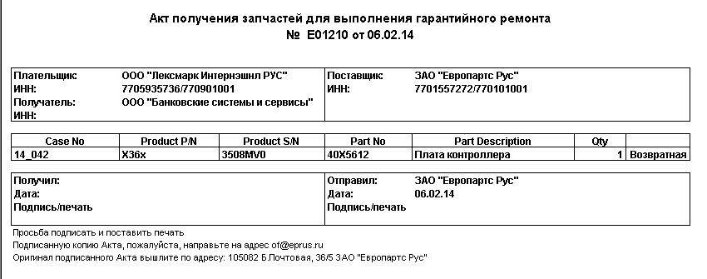

1. Printer key contact (plan to add)
2. Printer Host name or IP address (plan to add)
3. Printer serial number
4. Printer model
5. Ship to adress
6. Lexmark order number
7. Part number
8. Part discription
9. Qty

